The Chargers were founded in 1959 by Barron Hilton. They played their first season in the American Football League in Los Angeles, but because the LA Rams were so near, they moved to San Diego two years later. In the 1970 merger of the AFL and NFL, the Chargers helped form the AFC.
After spending 56 seasons in San Diego, the team went back to being the LA Chargers. The team spent four seasons under head coach Anthony Lynn where they went 33-31. There was only one memorable season in 2018 where they lost in the Divisional Playoffs to the New England Patriots. In 2021, the Chargers hired head coach Brandon Staley. In the past two seasons, they went 19-15. This 2023 season the Chargers are last in the AFC West with a 5-7 record. They have lost five games within a one-possession score.

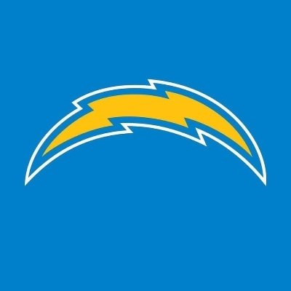
News Release
Dec. 2, 2023

Bill Belichick Announced as Head Coach for LA Chargers Starting in January

The Chargers initiate their program’s transformation.

LOS ANGELES — Bill Belichick will become the LA Chargers' new head coach starting in January. Belichick is leaving the New England Patriots after 24 seasons and six Super Bowl championships. He will remain the highest-paid coach in the NFL, signing a five-year $22 million contract with the Chargers.
Brandon Staley has been the Chargers coach since 2021. After going 19-15 in his first two seasons, Staley and the Chargers sit at 5-7 and last in the AFC West. Belichick is known for his experienced leadership, mentorship and strategy. His 49 years of NFL coaching experience will help reshape the Charger’s program.

Belichick is ready to get to work with the team and respects what Staley has built. He said, “Coach Staley’s obviously come in there and done a great job with creating confidence, and I’d say a lot of positive momentum on the team.”
“We are sad to see him go, but we are so thankful for everything Belichick has done for this Patriots program for the past 24 years,” said CEO Robert Kraft.
About LA Chargers
Now in their 64th season, the Los Angeles Chargers continue to stretch the imagination and put on the most exciting show in football. Behind the dramatic games, unforgettable highlights, beloved players, groundbreaking performances, idyllic Southern California setting and best uniforms in the NFL lies an uncompromising drive for success – one rooted in toughness, resilience and good old-fashioned hard work. A charter member of the American Football League, the franchise was established in Los Angeles in 1960 and called the Los Angeles Memorial Coliseum home during its first year of existence. From 1961 to 2016, the team played in San Diego and advanced to five of the first six AFL Championship games ever played. The Chargers claimed the 1963 AFL title and later joined the National Football League when the two leagues merged in 1970. Since the merger, the Chargers have gone on to appear in Super Bowl XXIX and have captured an additional 10 division titles. The Chargers were purchased by construction leader, philanthropist and real estate developer Alex G. Spanos in 1984 and have been under the guidance of Spanos' eldest son Dean, the team's current Chairman of the Board, since 1994. Dean Spanos' sons – A.G. Spanos, President of Business Operations, and John Spanos, President of Football Operations – oversee the day-to-day operations of the franchise. The Chargers returned to Los Angeles in 2017, began playing games in their new multi-billion-dollar SoFi Stadium home in 2020 and continue to redefine what an NFL franchise looks like in the 21st century. For more information, call 1-877-CHARGERS or visit http://www.chargers.com.

Contact: Addie Peterson
503-910-9165
addelinp@uoregon.edu

Pitches

To: Kaelen Jones
Why: Kaelen Jones is a staff writer for The Messenger in Los Angeles. He mainly covers the NFL and occasionally College Football. He’s covered athletics his whole career through writing and podcasts.

Subject Line: Chargers Hire Bill Belichick as Head Coach

Hi Kaelen,

I am reaching out because I came across several of your articles in The Messenger covering current NFL events. I specifically noticed your Keenan Allen story, and I wanted to send something your way you might find important to share with sports fanatics.

The LA Chargers are firing Brandon Staley and bringing in Bill Belichick. The head coach change will be effective after the 2023 season concludes for the Chargers and the New England Patriots.

As I am sure you know, both the Chargers and Patriots have been struggling this season. After 24 seasons with the Patriots, it’s time for Belichick to bring his coaching talents to a new program. He will sign a five-year $22 million contract with the Chargers.

With your LA location and impressive sports knowledge, would you be interested in sharing this on The Messenger?

Thank you,
Addie Peterson
Public Relations and Marketing Intern, LA Chargers
503-910-9165
addelinp@uoregon.edu

To: Bridget Condon
Why: Bridget lives in LA. She is an On Air Host and Reporter for the NFL Network and has written a lot of articles on the Chargers.

Subject Line: Chargers Hire Bill Belichick as Head Coach

Hi Bridget,

I am reaching out because I came across several of your articles on NFL Network. I specifically noticed your heavy coverage of the LA Chargers, and I wanted to send something your way you might find important to share with sports fanatics.

The LA Chargers are firing Brandon Staley and bringing in Bill Belichick. The head coach change will be effective after the 2023 season concludes for the Chargers and the New England Patriots.

As I am sure you know, both the Chargers and Patriots have been struggling this season. After 24 seasons with the Patriots, it’s time for Belichick to bring his coaching talents to a new program. He will sign a five-year $22 million contract with the Chargers.

With your LA location and impressive work with the NFL Network, would you be interested in sharing this?

Thank you,
Addie Peterson
Public Relations and Marketing Intern, LA Chargers
503-910-9165
addelinp@uoregon.edu

Audio News Release

Dec. 2, 2023 :60 sec
Addie Peterson
addelinp@uoregon.edu
503-910-9165

The L-A Chargers already have a new coach signing for next season. Bill Belichick [beh-luh-chuhk] will become the head coach starting in January. He spent twenty-four seasons with the New England Patriots and won six Super Bowls. Belichick is signing a five-year twenty-two-million-dollar contract. And remains the highest-paid coach in the league.

The current head coach, Brandon Staley [stay-lee], has been with the team since 2021 now. He’ll be leaving the team with a losing record and dead last in the A-F-C West.

[Actuality, 8 sec:]

[Belichick: “Coach Staley’s obviously come in there and done a great job with creating confidence, and I’d say a lot of positive momentum on the team.”]

This is a significant move for the Chargers as the team looks to transform its program. Belichick has been coaching in the NFL for forty-nine years now. He is arguably one of the best coaches in NFL history.

He is looking forward to getting started with the team, especially Justin Herbert.

[Actuality, 8 sec:]

[Belichick: “He’s as good a quarterback as I’ve seen come out here in quite a while. Especially as it fits the pro game. I don’t think you’re going to find too many better than him.”]

Get ready Chargers fans! Belichick will take over once the 2023 season concludes.

Bio

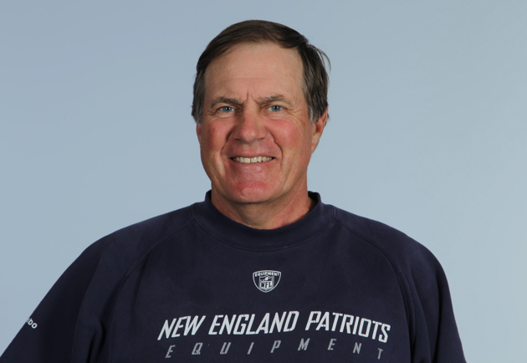
Bill Belichick
Head coach and general manager
New England Patriots

Bill Belichick is the head coach and general manager for the New England Patriots. He has led the team for 24 years forming a 264-117-0 record.

Belichick has been in the NFL since 1975. He started as an assistant with the Baltimore Colts. He transferred to the Detroit Lions and then the Denver Broncos before becoming the head coach of the New York Giants for 12 years and the Cleveland Browns for four years. He was an assistant with the Patriots for one year, then worked with the New York Jets for three years. In 2000, he was appointed head coach of the Patriots.

In his career, Belichick has won eight Super Bowls. He won his first two rings as the defensive coordinator for the Giants. He achieved the following six Super Bowls with the Patriots which is the most for an NFL head coach. Belichick worked closely with quarterback Tom Brady to grow a successful Patriots program for over 20 years. He also led the Patriots to nine AFC championship games, the most in the history of the Super Bowl.

Belichick grew up in Annapolis, Maryland. He graduated from Wesleyan University before following the footsteps of his father as a football coach. Belichick received an honorary doctorate and the university’s highest honor of achievement for alumni, the Baldwin Medal.

